Zachary Kondak and Ryan Rose

MUSI 6201

13 September 2017

Assignment 1: Pitch Tracking using ACF

**…generate a test signal …apply your myPitchTrackerACF() and plot the f0 curve… . …plot the absolute error per block and discuss the possible causes for the deviation.**

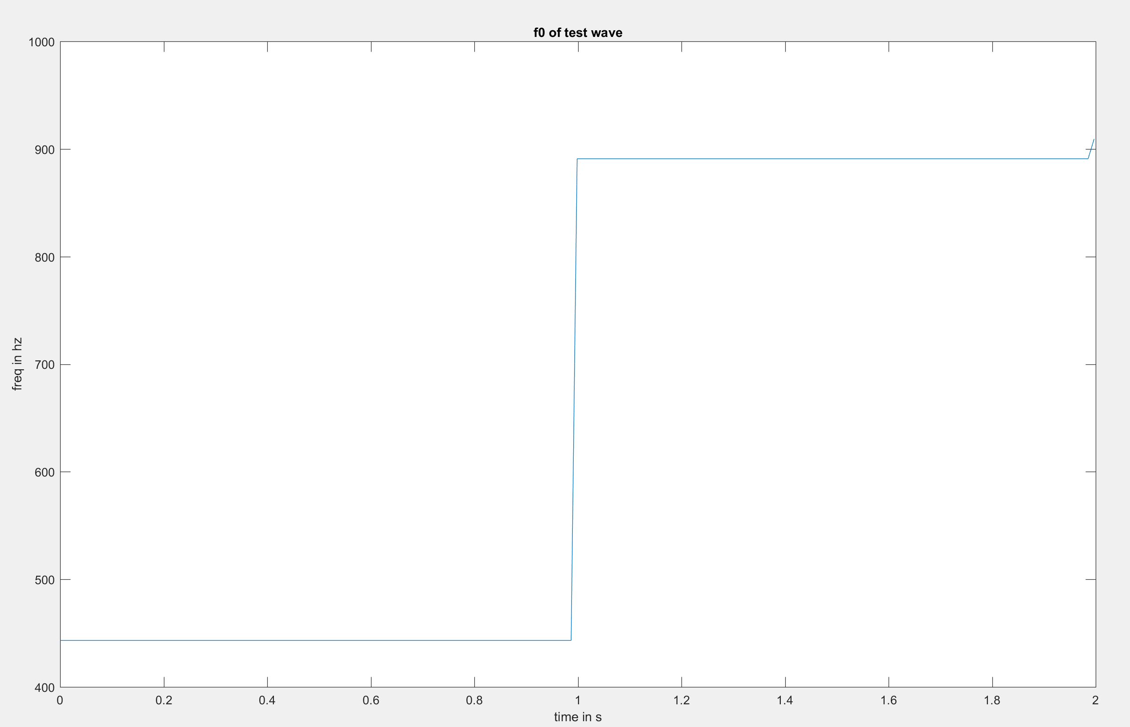

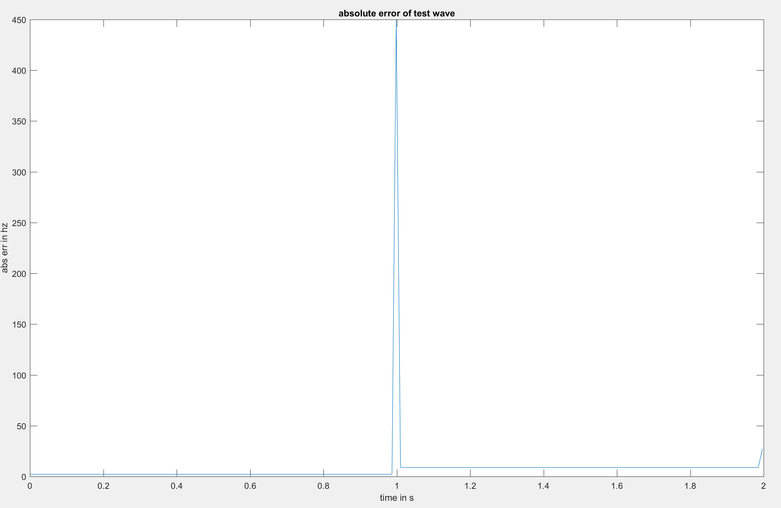

Overall, the absolute error of our pitch tracker per block is very low, with an outlier at the blocks where the frequency stepped from 441 Hz to 882 Hz. This is because the tracker was miscalculating f0 to be the value either before or after the step, as the absolute error was always the difference between the steps.

Training set 1 (01-D_AMairena):

rms1 = 565.6718

Training set 2 (24-M1_AMairena-Martinete):

rms2 = 923.9297

Training set 3 (63-M2_AMairena):

rms3 = 459.4178

**What are the potential solutions to improve their performances?**

1. Better peak detection – our peak detection method is imprecise when peaks are not a single value (i.e. local maxima is equal for multiple consecutive samples). Furthermore, the median filter used to reduce erroneous peaks creates additional error.
2. Better ACF computation – since we zero-pad our lagged signal during the ACF process, error is accrued.